CPR for Adults
Scene is safe!
C-CIRCULATION (3 steps):
- Check responsiveness and for breathing – “shake and shout” or if trauma suspected “touch and talk” – look for chest rise – if no response or breathing or abnormal breathing go to next step
- Call a Code Blue if in hospital or if out of hospital Call 9-1-1
- a. Check Circulation- by palpating a carotid/femoral pulse (within 10
seconds). If no definite pulse within 10 seconds then, begin chest
compressions. If a definite pulse is felt, then give 1 breath every 5-6
seconds. Recheck pulse every 2 minutes or 5 cycles.
b. Provide - CIRCULATION w/chest compressions and ventilations
(30:2) for at least 100-120 compressions per minute, “hard and fast”, at
least 2 inches deep (not further) with minimal interruptions. Allow
for complete recoil of the chest after each compression.

A-AIRWAY: Open the AIRWAY using head-tilt-chin lift, if trauma suspected, then use jaw thrust method. Even if trauma suspected and you are the only rescuer available, then open the airway using head-tilt-chin lift.

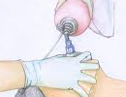
B- BREATHING: Assessment of this was done in step one - Provide BREATHING (2 breaths) allowing the chest to rise each time, give each breath over 1 second. Avoid excessive ventilations. If the breath does not go in, reposition the head by head-tilt-chin lift and attempt to deliver 2 breaths. Utilizing a bag-valve-mask (BVM) requires a good seal – E-C method, E with 3 fingers along jawbone and C with thumb and forefinger on the mask.

D-DEFIBRILLATE (4 steps):
- Turn on AED(Automated External Defibrillator)
- Connect to pt – connect patches to patient following diagram on patches
- Clear pt to analyze - Checks for a shockable rhythm: (Pulseless Ventricular Tachycardia [V. Tach.] or Ventricular Fibrillation [V. Fib.]),
- Clear pt to Shock 1X at 120-200J (biphasic) or 360J (monophasic) – Chant “I’m clear, you’re clear, we’re all clear!!!”
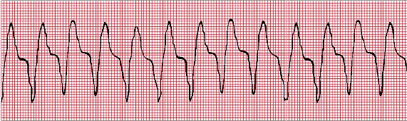
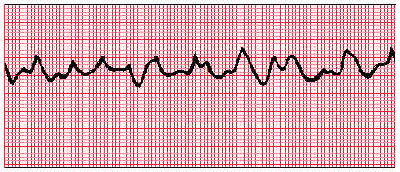
- POWER ON the AED (voice prompting will guide in all other steps)
- ATTACH the electrode pads to the patient
  - Can now be used on infants through adults
  - Use adult pads for everyone 8 years and above
  - Use child pads and for children 0-8 years old
  - Can use adult pads and voltage on all patients if pediatric patches/voltage is not available.
  - Peel the backing away from the electrode pads
  - If the patient’s chest is hairy, the pads may not stick
  - If the patient is wet, make sure you dry the chest area
  - Avoid medication patches and implanted devices – but do not delay attaching electrodes for this reason.
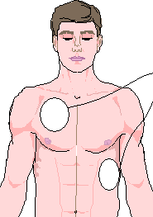
- ATTACH the connecting cables to the AED box, some may be preconnected
- Listen to the prompts!
- Clear the patient and allow the AED to ANALYZE the rhythm
  - Do not touch the patient or allow anyone else to touch the patient
  - You may need to push a button, or it may be automatic after a verbal prompt
- SHOCK ADVISED or NO SHOCK ADVISED will be indicated
  - If a shock is advised, then the AED will charge
  - Clear the patient: “I’m clear, you’re clear, everyone’s clear!”
  - Push the SHOCK button – purpose is to eliminate the rhythm
  - If no shock advised, skip directly to number 6.
- Resume CPR beginning with chest compressions
  - Do not remove the pads
  - Do not shut off the AED
  - After 2 minutes (5 cycles of compressions to ventilations), then the AED will prompt to reanalyze the rhythm.
Note: as the patient is smaller in size, the AED pad placement is best as Anterior/ Posterior.
CPR for Children (1 Year to Puberty)
Puberty = Female-breast development, Male-arm, facial, or chest hair.
Scene is Safe!
C-CIRCULATION (3 steps):
- Check responsiveness and for breathing – “shake and shout” or if trauma suspected “touch and talk” – look for chest rise – if no response or no breathing or abnormal breathing go to next step
- Call a Code Blue (9-1-1) if witnessed collapse/wait and call after 5 cycles of CPR if not witnessed (found unresponsive).
- a. Check CIRCULATION - by palpating a carotid/femoral pulse (within
10 seconds). If no pulse or < 60 bpm, begin chest compressions. If a
pulse > 60bpm is felt, then give 1 breath every 3-5 seconds.
Recheck pulse every 2 minutes or 5 cycles.
- Provide - CIRCULATION w/chest compressions and ventilations (30:2-for 1 person /15:2-for 2 person) for at least 100-120 compressions per minute, “hard and fast”, at least 1/3 depth of chest, about 2 inches. May use 1 or 2 hands for CPR. Allow for complete recoil of the chest after each compression.

A-AIRWAY: Open the AIRWAY using head-tilt-chin lift, if trauma suspected, then use jaw thrust method. Even if trauma suspected and you are the only rescuer available, then open the airway using head-tilt-chin lift.

B- BREATHING: Assessment of this was done in step one - Provide BREATHING (2 breaths) allowing the chest to rise each time, give each breath over 1 second. If the breath does not go in, reposition the head by head-tilt-chin lift and attempt to deliver 2 breaths. Utilizing a bag-valve-mask (BVM) requires a good seal – E-C method, E with 3 fingers along jawbone and C with thumb and forefinger on the mask.
D-DEFIBRILLATE (4 steps):
- Turn on AED (Automated External Defibrillator)
- Connect to pt – connect patches to patient following diagram on patches
- Clear pt to analyze - Checks for a shockable rhythm: (Pulseless Ventricular Tachycardia [V. Tach.] or Ventricular Fibrillation [V. Fib.]),
- Clear pt to Shock 1X at 120-200J (biphasic) or 360J (monophasic) - Chant “I’m clear, you’re clear, we’re all clear!!!”

CPR for Infants (up to 1 year of age)

C-CIRCULATION (3 steps):
- Check responsiveness and for breathing – tap the foot and look for chest rise – if no response or breathing or abnormal breathing go to next step
- Call a Code Blue (9-1-1) if witnessed collapse/wait and call after 5 cycles of CPR if not witnessed (found unresponsive).
- a. Check CIRCULATION - by palpating a brachial pulse (two fingers on the inside of upper arm between the shoulder and the elbow) within
10 seconds. If no pulse or < 60 bpm, begin chest compressions. If a
pulse is felt > 60 bpm, then give 1 breath every 3-5 seconds.
Recheck pulse every 2 minutes or 5 cycles.

- Provide - CIRCULATION w/chest compressions and ventilations (30:2-for 1 person /15:2-for 2 person) for at least 100-120 compressions per minute, “hard and fast”, at least 1/3 depth of chest same as a child. Use 2 fingers for compressions, one finger below the nipple line for or the two thumb-encircling hands technique.
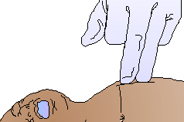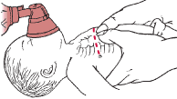
A-AIRWAY: Open the AIRWAY using head-tilt-chin lift to a neutral position
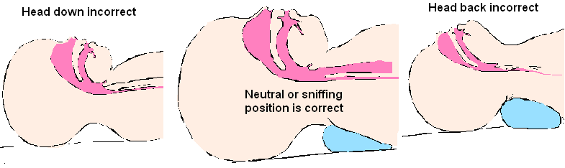
B- BREATHING: Assessment of this was done in step one - Provide 2 breaths (puffs) allowing the chest to rise. Provide breaths by mouth of the rescuer to-mouth-and-nose of the infant or with bag-valve-mask. If the breath does not go in, reposition the head by head-tilt-chin lift and attempt to deliver the 2 breaths.

D-DEFIBRILLATE ( 4 steps):
- Turn on AED(Automated External Defibrillator)
- Connect to pt – connect patches to patient following diagram on patches
- Clear pt to analyze - Checks for a shockable rhythm: (Pulseless Ventricular Tachycardia [V. Tach.] or Ventricular Fibrillation [V. Fib.]),
- Clear pt to Shock 1X at 120-200J (biphasic) or 360J (monophasic)

Relief of Choking
Mild Airway Obstruction:
Signs of Severe Airway Obstruction:
- Poor or no air exchange
- Weak, ineffective cough or no cough
- High pitched noise while inhaling or no noise at all
- Increased respiratory difficulty
- Possible cyanosis (turning blue)
- Unable to speak
- Clutching the neck with the thumb and fingers (universal choking sign)
- Unable to move air
Rescuer actions:
- Ask the patient if he or she is choking. If the patient nods yes and cannot talk, severe airway obstruction is present, and you must activate the emergency response system
Principles of when to act:
-As long as good air exchange continues,
encourage the patient to continue
spontaneous coughing and breathing efforts.
-Do not interfere with the patient’s own
attempts to expel the foreign body, but stay
with the patient and monitor his/her
condition.
-If this persists, then activate the emergency
response system.
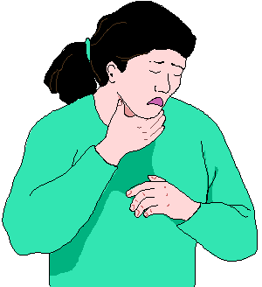
Universal
Choking Sign

- Stand or kneel behind the patient and wrap your arms around the patient’s waist.
- Make a fist with one hand.
- Place the thumb side of your fist against the patient’s abdomen, in the midline, slightly above the navel and well below the breastbone.
- Grasp your fist with your other hand and press your fist into the patient’s abdomen with a quick upward thrust.
- Repeat the upward thrusts until 1) the object is expelled or 2) the patient becomes unresponsive.
- Give each thrust with a little different movement to expel the object.
- If the patient becomes unresponsive, lay the patient on a firm surface, and begin the steps of CPR + add the step of looking for a foreign object.
- The extra step is to look for a foreign object when opening the airway and remove it if found. DO NOT DO BLIND FINGER SWEEPS ON ANYONE OF ANY AGE.
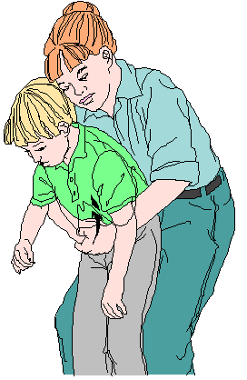
- For infants when responsive, provide 5 back slaps and then 5 chest compressions using the 2-finger method. When unresponsive, treat like infant CPR with 1 extra step. Look for a foreign object in the mouth when opening the airway and giving breaths.
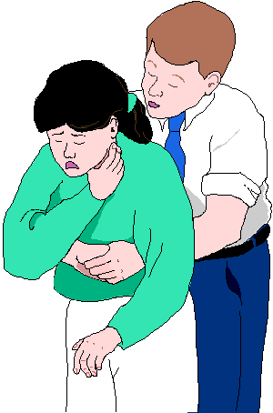
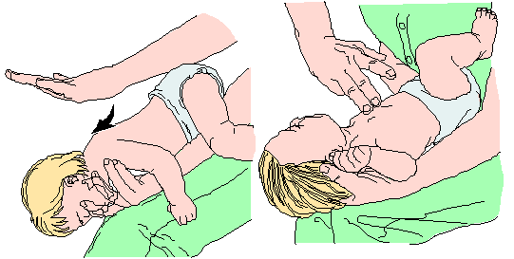
- Special Notes:
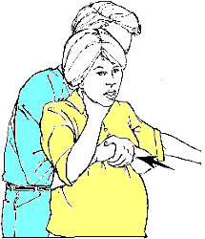
- If a patient is pregnant or too large to wrap your arms around the stomach, one would apply chest compressions to relieve the obstruction. This can be done behind the patient or have the patient stand against the wall or lie down and perform chest compressions as if doing CPR.
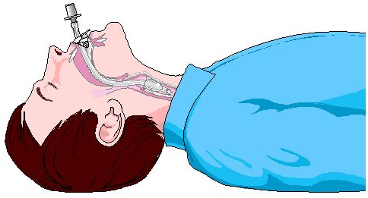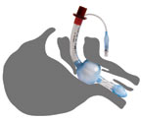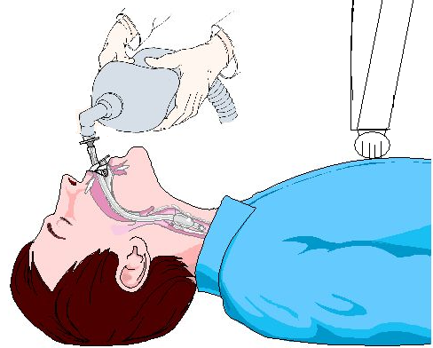
- Once an advanced airway is in place, chest compressions can be continuous (at a rate of at least 100-120 per minute) and no longer need to be cycled with ventilations. A person can ventilate the patient with a bag valve mask at 1 breath every 6 sec (about 10 breaths per minute).
- When calling 9-1-1, it is important to know where you are and making sure help can find you (providing an address, street location, building name, best door to come in, etc. is important).
- If a barrier device is not available for airway management, then move to chest compressions, only until advanced help has arrived and can safely take over care.
- Best chances for success in a team situation is for everyone to know their limitations and let the team leader know early on.
- Best way of running a team is for everyone to know their role.
- Post–Cardiac Arrest Care and Education, Implementation, and Teams (responsibilities, communication, effectiveness, and leadership roles).

